BABU BANARASI DAS UNIVERSITY


Session- 2025- 26

Submitted To :
Mr. Vikas Kumar
Submitted By :

Adarsh prajapati

Health Risk Prediction using CHAID Decision Tree in IBM SPSS Modeler

🎯 Objective:
To predict a person’s health risk level (low/high) based on their lifestyle and health-related factors — such as age, weight, exercise, smoking, alcohol, and sleep habits — using the CHAID classification algorithm.
Outcomes/Learning
You will learn how to build a classification model to predict customer churn using CHAID in IBM SPSS Modeler. The project
demonstrates the process of data preparation, model configuration, execution,
and interpretation of results .

Required Tool
: The tool used for this project is IBM SPSS Modeler
Working : To predict a person’s health risk level (low/high) based on their lifestyle and health-related factors — such as age, weight, exercise, smoking, alcohol, and sleep habits — using the CHAID classification algorithm.

step 1: Import data
Loaded the dataset (churn_prediction.csv) into SPSS Modeler and
confirmed all fields were correctly recognized.
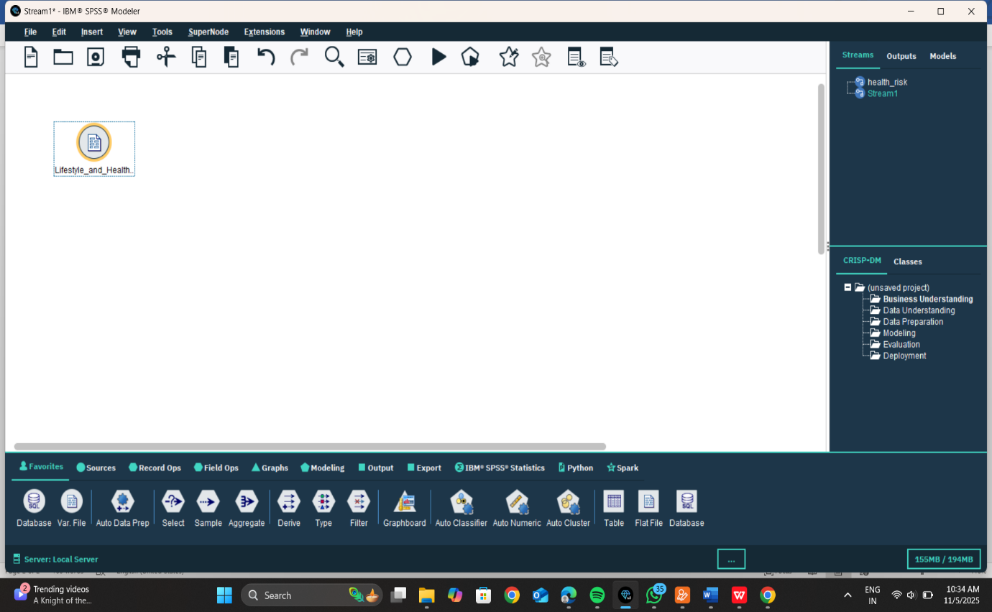

Step 2: Inspect and Prepare Data:
Checked for missing or invalid values and corrected any formatting or
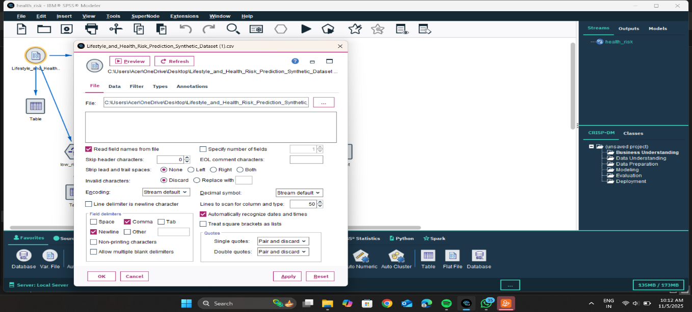
dataset into the stream for the next steps — data understanding, preparation, and modeling
- Importing a CSV file that contains data for your health risk prediction project.
- Options like “Read field names from file” and “Comma” as the field delimiter are selected — meaning the first row contains column names and data fields are separated by commas.
- Encoding and decimal symbols are set to default.
- It automatically recognizes dates and times and handles text delimiters properly.
Once you click Apply → OK, SPSS will load the dataset into the stream for the next steps — data understanding, preparation, and modeling.
Step 3:
• You’re assigning each variable a Measurement type (e.g., Continuous, Nominal, Flag).\ • Columns like age, weight, height, sleep are Continuous (numeric values). • exercise and sugar_intake are Nominal (categorical). • smoking and alcohol are Flag (yes/no type). • The Role is set to Input, meaning these are predictor variables used to build your model
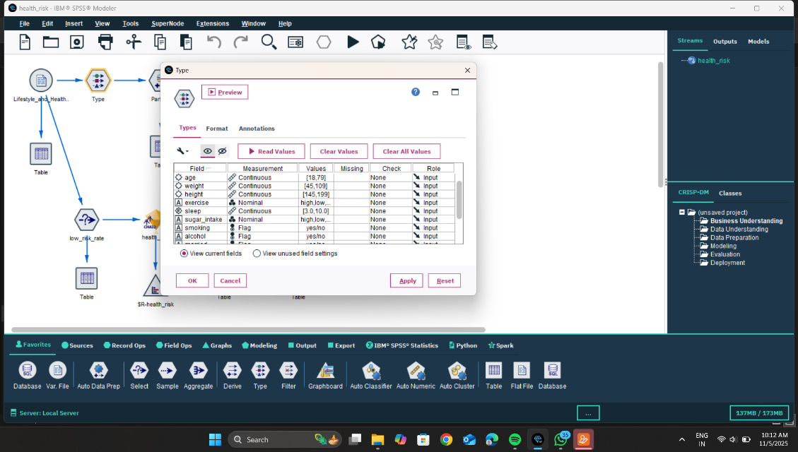

STEP:4
- Partition type: “Train and test” is selected → dataset is split into two parts.
- Training partition size: 70% → used to build (train) the model.
- Testing partition size: 30% → used to test and validate the model’s accuracy.
- Repeatable partition assignment: Checked → ensures the same data split every time you run (controlled by the Seed value 1234567).
- Labels: “1_Training” and “2_Testing” → define the names for each partition.
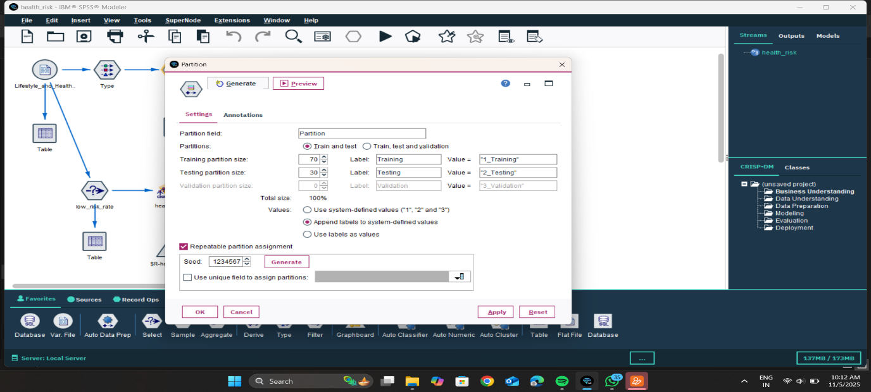
✅ Purpose: To divide data into 70% training and 30% testing so the prediction model (like CHAID, C&R Tree, etc.) can be trained and evaluated properly.

STEP :5
- The target variable is health_risk.
- The predictor variables (inputs) are factors like age, weight, height, exercise, sleep, sugar_intake, smoking, and alcohol.
- The stream on the left shows the data flow, including data input (Table nodes), partitioning (training/testing split), modeling (CHAID nodes), and evaluation (output tables).
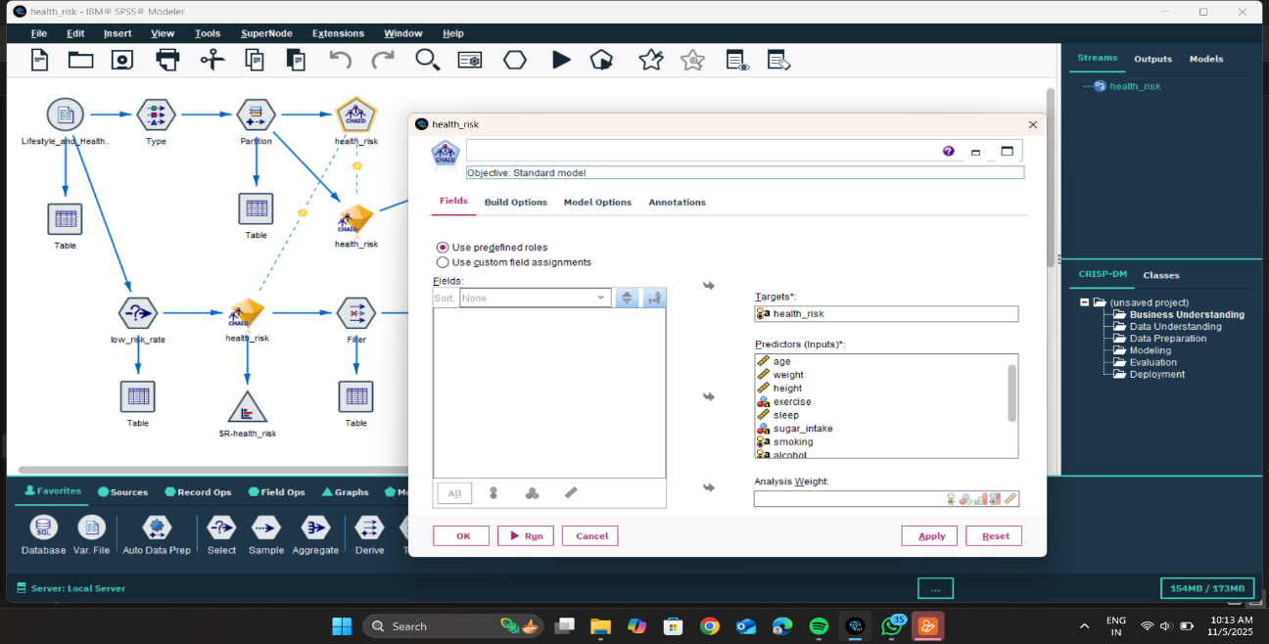
- This setup aims to analyze how lifestyle factors influence health risk.

STEP 6:
In this step, you are using the Graph node to visualize the distribution of the target variable health_risk.
- Field Selected: health_risk
- Plot Type: Bar Chart (default)
- Purpose: To see how many people fall into each category such as Low, Medium, and High health risk.
- Sorting Options:
  - Alphabetic sorts labels alphabetically
  - By count sorts bars by number of records in each category
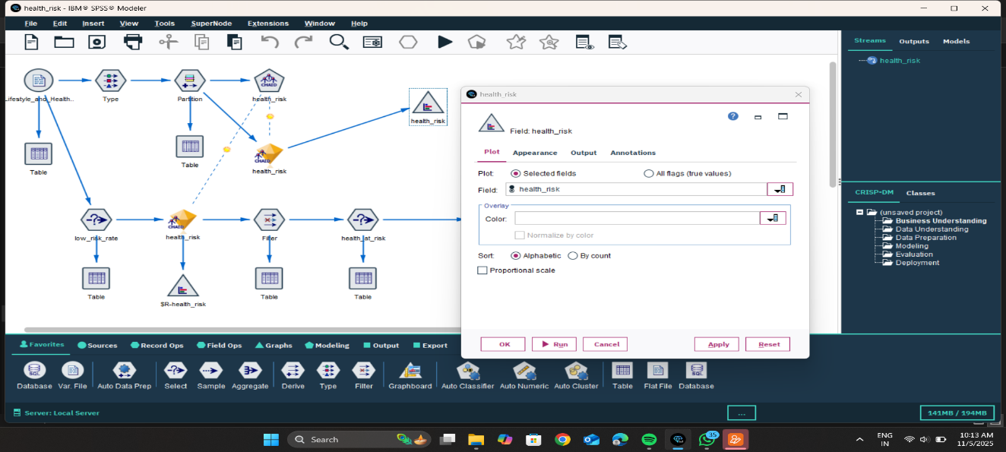
After setting this, you click Run to generate the chart.
STEP 7:
are using a Select node named low_risk_rate to filter the dataset.
- Mode: Include
- Condition:

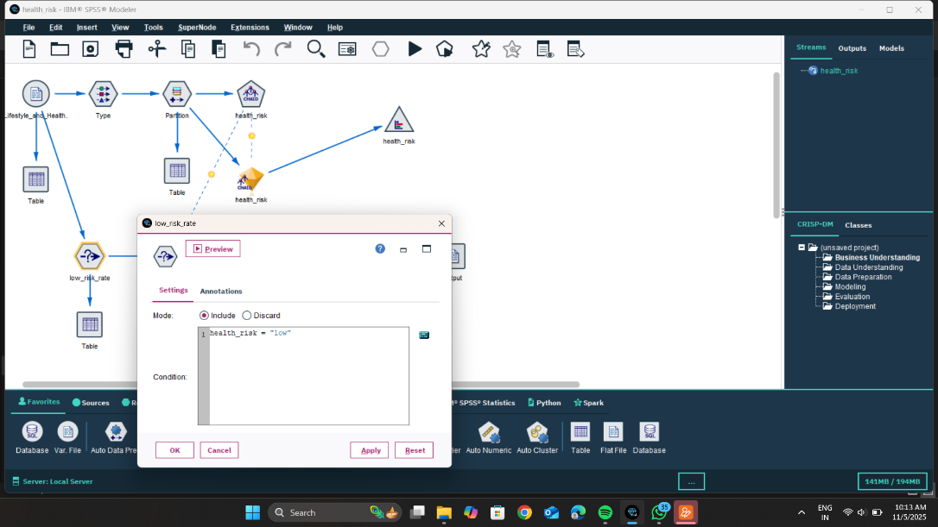
Purpose:This step keeps only those individuals whose health risk level is classified as "low".
All other records (medium and high risk) are removed from this filtered output.

STEP 8:
This screen shows the Predictor Importance chart for the model predicting health_risk.
- The model has identified which factors have the strongest influence on determining health risk.
- Age is the most important predictor.
- Next important factors are:
  - Exercise level
  - BMI (Body Mass Index)
  - Alcohol consumption
- Less influential factors:
  - Smoking
  - Sleep
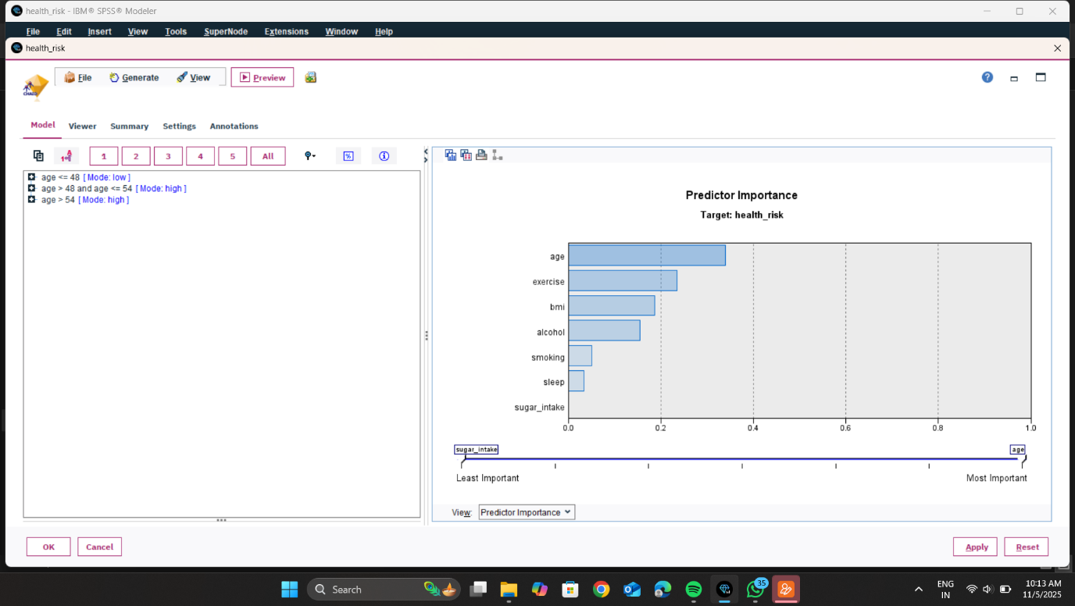
  - Sugar intake (least effect)
STEP 9:

Filter Node (Selecting Only Required Fields)
In this step, the Filter node is used to keep only the important variables needed for the next analysis.
- Many fields (like weight, height, exercise, sleep, etc.) are being removed (marked with a red X).
- Only 3 fields are being kept (output):
  - age
  - health_risk
  - (and one more field depending on selection, likely BMI or result variable)

Purpose:
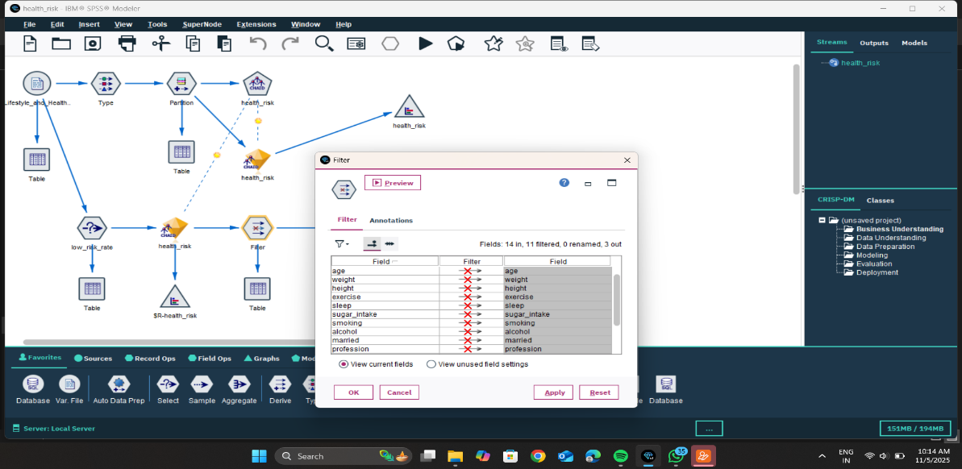
This step reduces unnecessary data and keeps only the fields needed for the final output or report.

STEP 10:
This is the Output node used to save/export your final processed data to a file.
- Export file: Shows the location where your data will be saved.
- Overwrite: Replaces the file if it already exists.
- Include field names: Ensures column names appear in the exported file.
- Comma / Tab / Space: Selects how values are separated (commonly Comma for CSV).
- Run: Saves the dataset to the specified path.

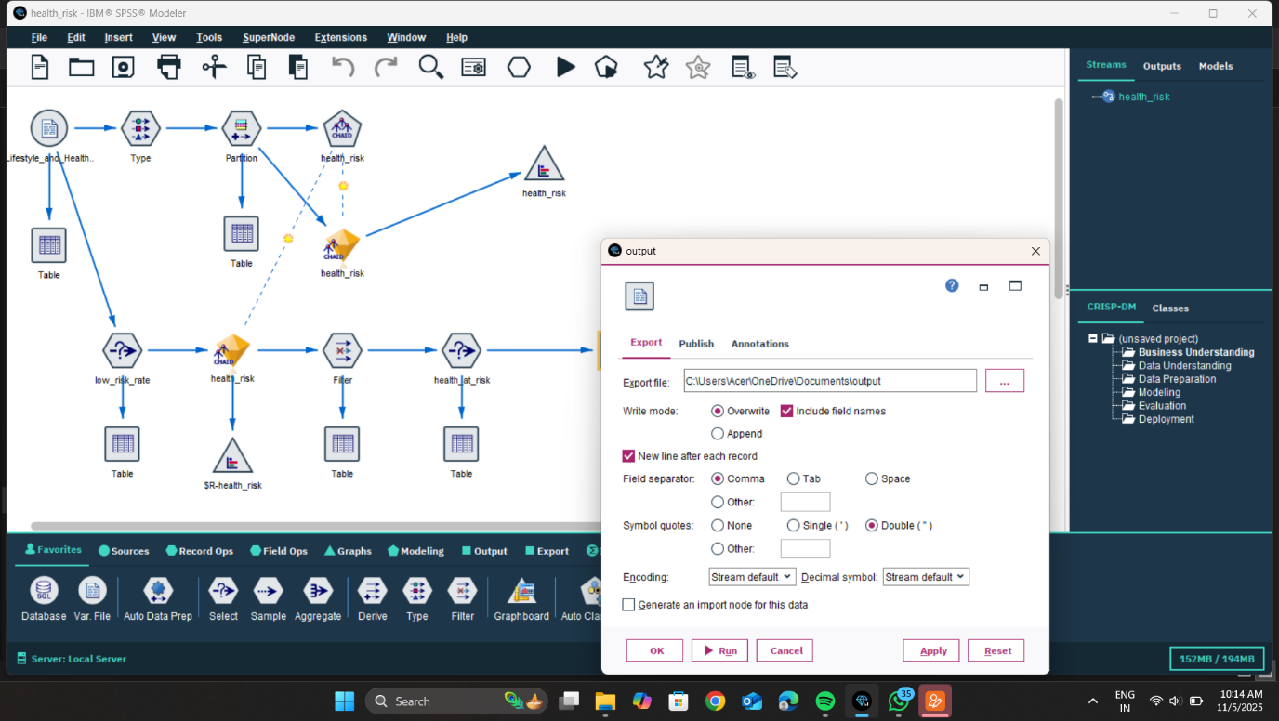
FINIAL OUTPUT : Compared actual vs. predicted churn rates to evaluate model performance and interpret findings
for actionable retention planning. The complete SPSS Modeler stream (shown below) illustrates
the workflow from data import to churn prediction and analysis:
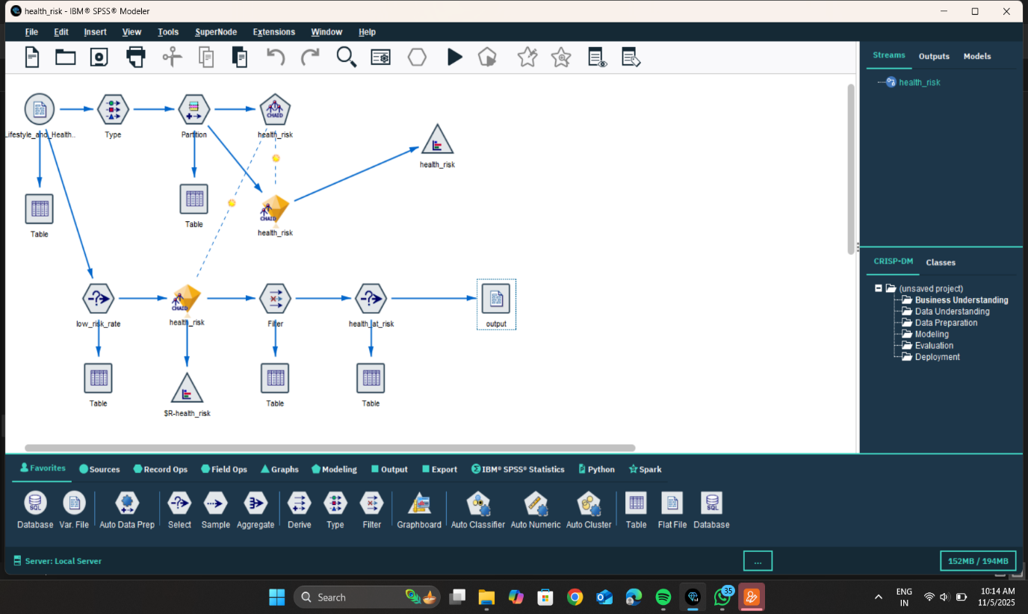

Conclusion
In this project, lifestyle data was analyzed to predict a person’s health risk level. Using a decision tree model (CHAID), the system identified which habits and characteristics have the strongest impact on health risk. The results showed that age, exercise, and BMI are the most important factors in determining whether someone has low or high health risk.
The data was then filtered to separate individuals into low-risk and high-risk groups, and these results were exported for further review or reporting.
Overall Conclusion:
This analysis demonstrates that healthier lifestyle choices—especially regular exercise, maintaining a healthy weight, and managing habits like smoking and alcohol—play a major role in lowering health risks. The model can help identify individuals at higher risk and support preventive health planning.

Summary
The stream analyzes lifestyle data to determine a person’s health risk level.
The data is prepared, split, and used to build a CHAID decision tree model that predicts whether health risk is low or high.
Key factors that influence health risk are identified (such as age, exercise, and BMI).
Finally, the results are separated into groups (low-risk and high-risk) and exported for further use.

